Data description

AFSPnetwork.jpg: This is the A matrix, single-line arrows represent one-way connections, while double-line arrows represent a pair of one-way connections in opposite directions. This describes the intrinsic/default connectivity between the brain regions (connectivity without any stimulations)

AFSPnetwork_model1.jpg: This is the B matrix; it describes how the experimental stimulus changes the default connections between the brain regions. The colored inputs should be 1s, all other connections would be 0.

AFSPnetwork_model2.jpg: This is another B matrix (since we are guessing how the experimental stimulations modify brain connection, we can propose different B matrices and, in the end, compare model performance to choose the B matrix that had the best results.)

C matrix: Describes which brain regions are directly activated by the experimental stimulus. In this project, there is only one stimulus, and it directly activates IOG-L and IOG-R. So, it is just a vector of zeros except at the indices corresponding to the regions IOG-L and IOG-R, where you'd have ones.

D matrix: They are not used for calculation in for this project, so it’s just a matrix of 0s.

PatientData.mat: This file contains all the patient’s BOLD signals collected from experiment, to access them, they are stored in PatientData.mat -> Yall. Each row represents a patient, and each column represents a brain region. You can click into a cell to access the series of BOLD signal at each brain region for each patient across time. Each column corresponds to the brain regions described in PatientData.mat -> roi -> label

U.mat: This file contains the stimulus input, it describes when during the experiment, a stimulus is given to the patients. When plotted, this should just look like spikes of events with the same height, but at discrete times. A spike indicates a stimulus was given. You can access this data via U.mat -> DCM -> U -> u, this U applies to all patients, so you don’t need a different U for each patient.

Running the p-dcm:
Use run_pdcm.py in the code folder. Currently, all matrices and data have been set up, you only need to change the subject_idx (line 36) each time when you run if you want to run on different subjects. I use VScode to run this code, make sure to load the entire code folder on VScode, and run via the code directory, because other files in the code directory is required to run run+pdcm.py.
If you start at base, cd to code.
The way I run it is in the terminal in VScode, I type:
python -m utilities.run_pdcm (because run_pdcm is in the utilities folder)

Then you should see something like this:
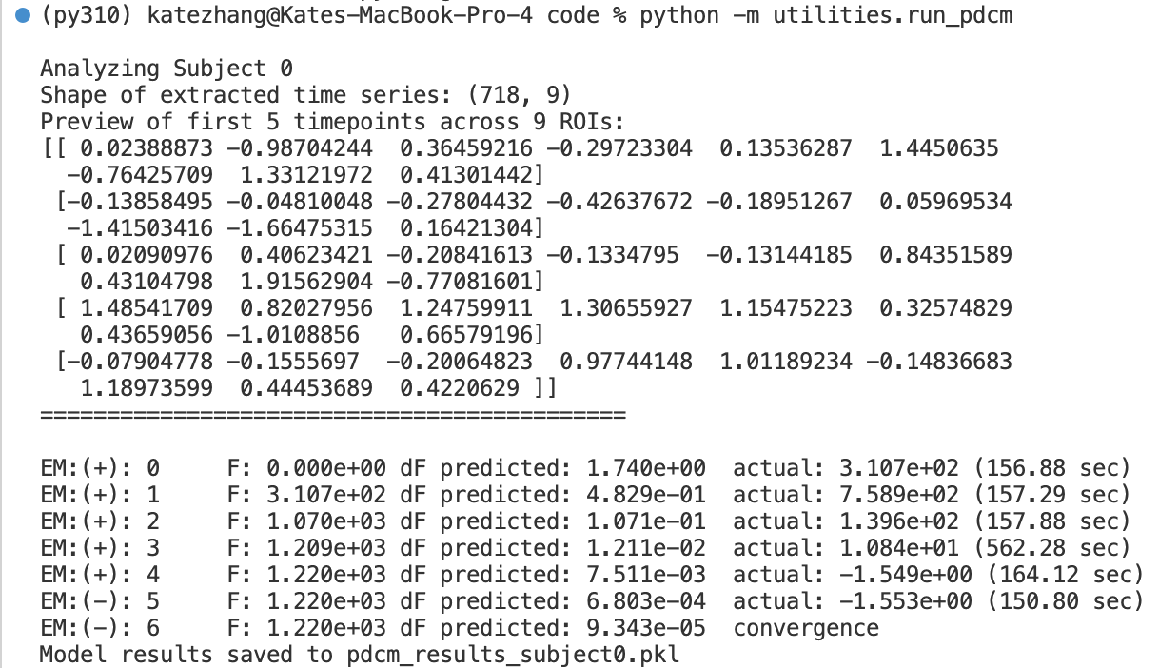

Each EM is representing how the model is fitting, positive means the results are becoming more closely fitted to actual data, negative means we are not getting any better, when the model can’t get any better than the previous trial, it converges.

You can see on the last line model results saved to “”
You can then load this result into analyze_connectivity.py (just put the name of that pkl file in line 12, you don’t need to change anything else), then while still in the code directory, type :
python -m analyze_connectivity.

Then, you would see the connectivity matrix, a connectivity map, the actual vs predicted bold for each brain regions (if model was correct, these two traces should be similar), and the U plot. Note that these diagram will not appear at the same time, they appear one at a time, you need to close the current diagram for the next diagram to appear, you need to close all diagrams for this file to end running.

Current Issues:
The connectivity matrix produced are always 0, suggesting patient’s BOLD data were not loaded successfully, or there’s something wrong with the model calculation.
Suggest to run line 119 in run_pdcm.py and see what is produced after priors are calculated, if at this point the results are 0, look through priors and see what’s causing the 0.

